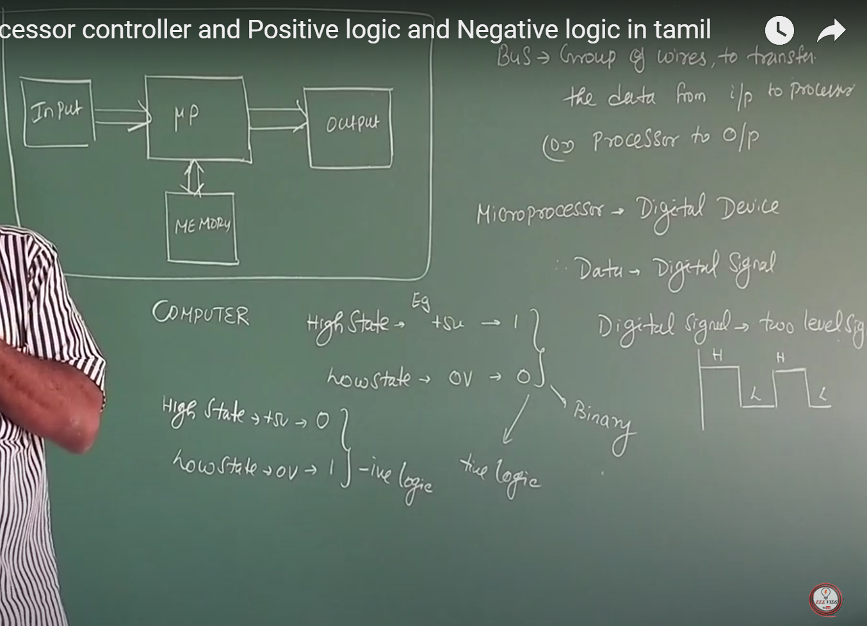

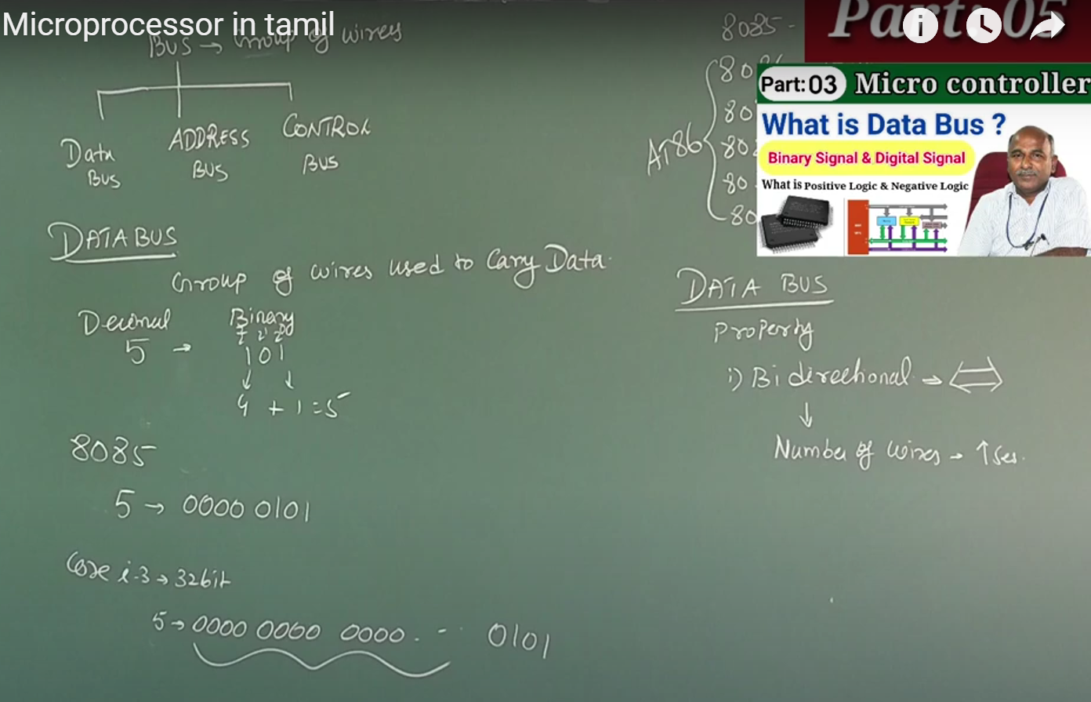
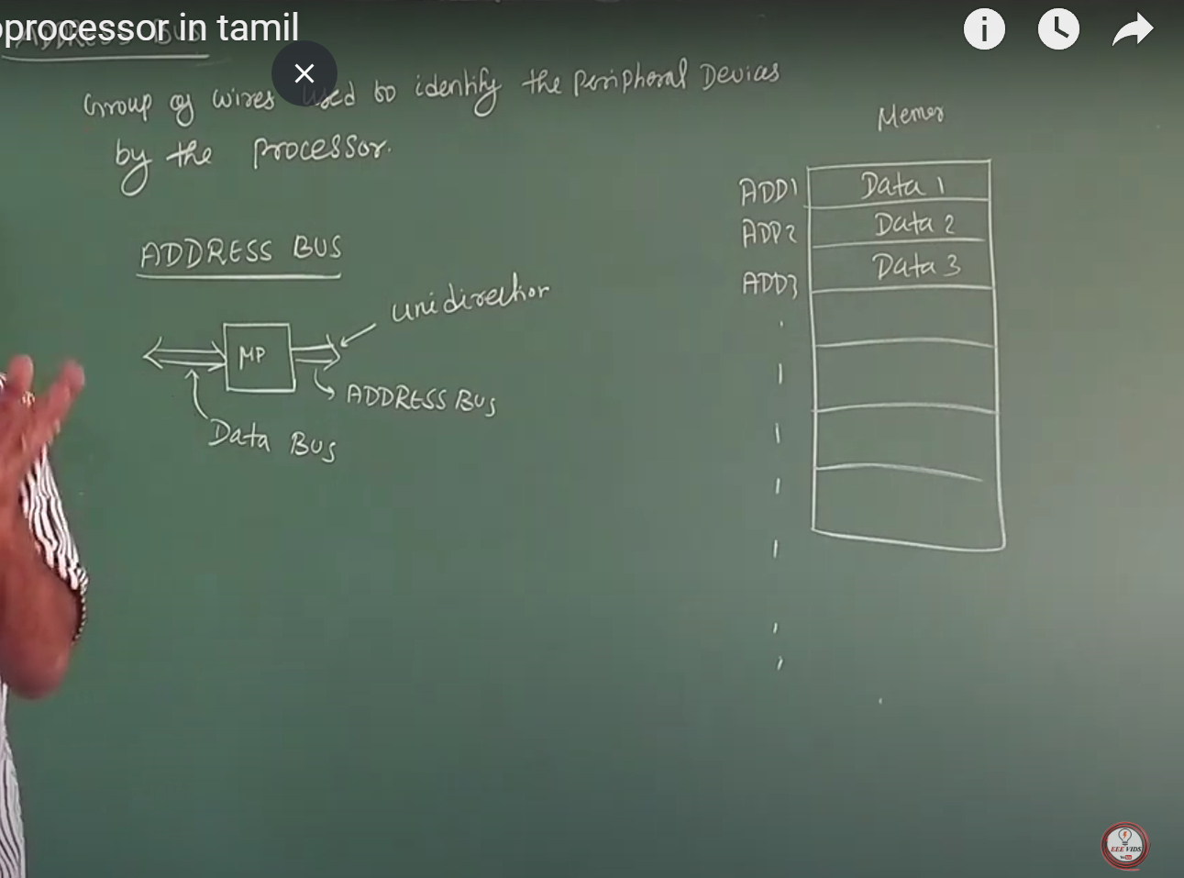
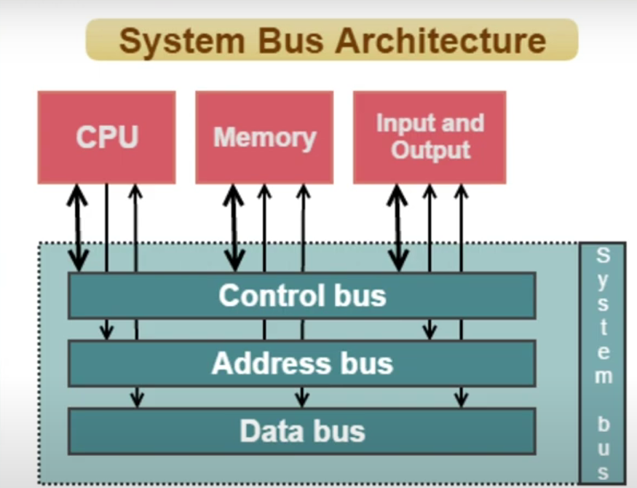

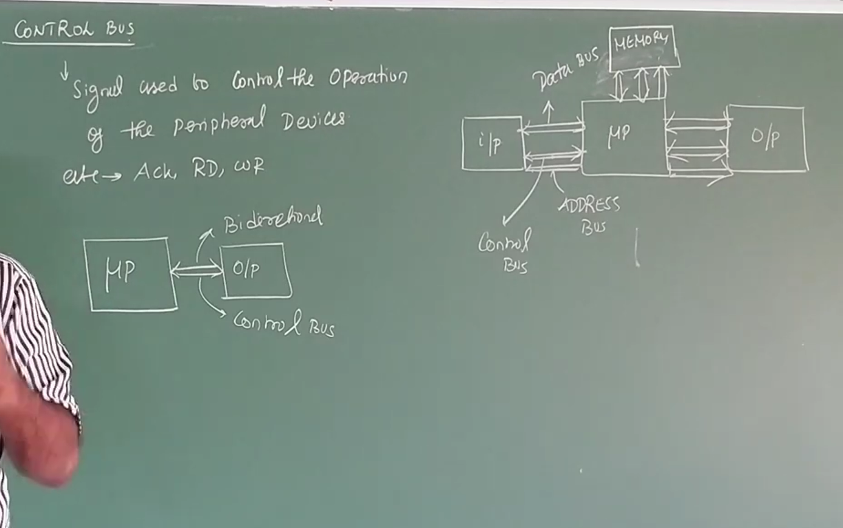

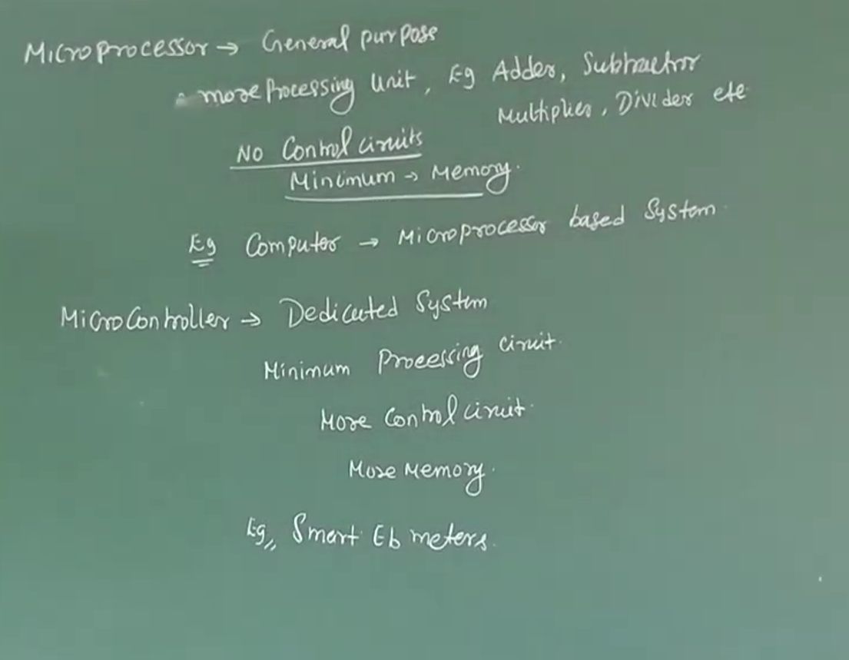
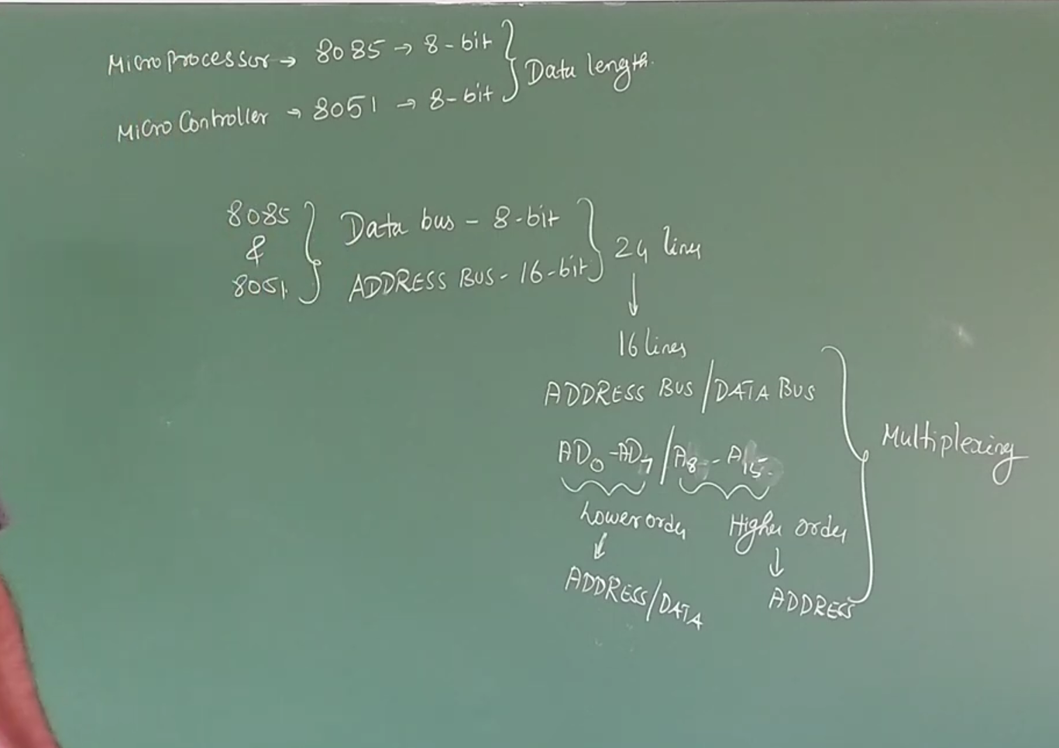
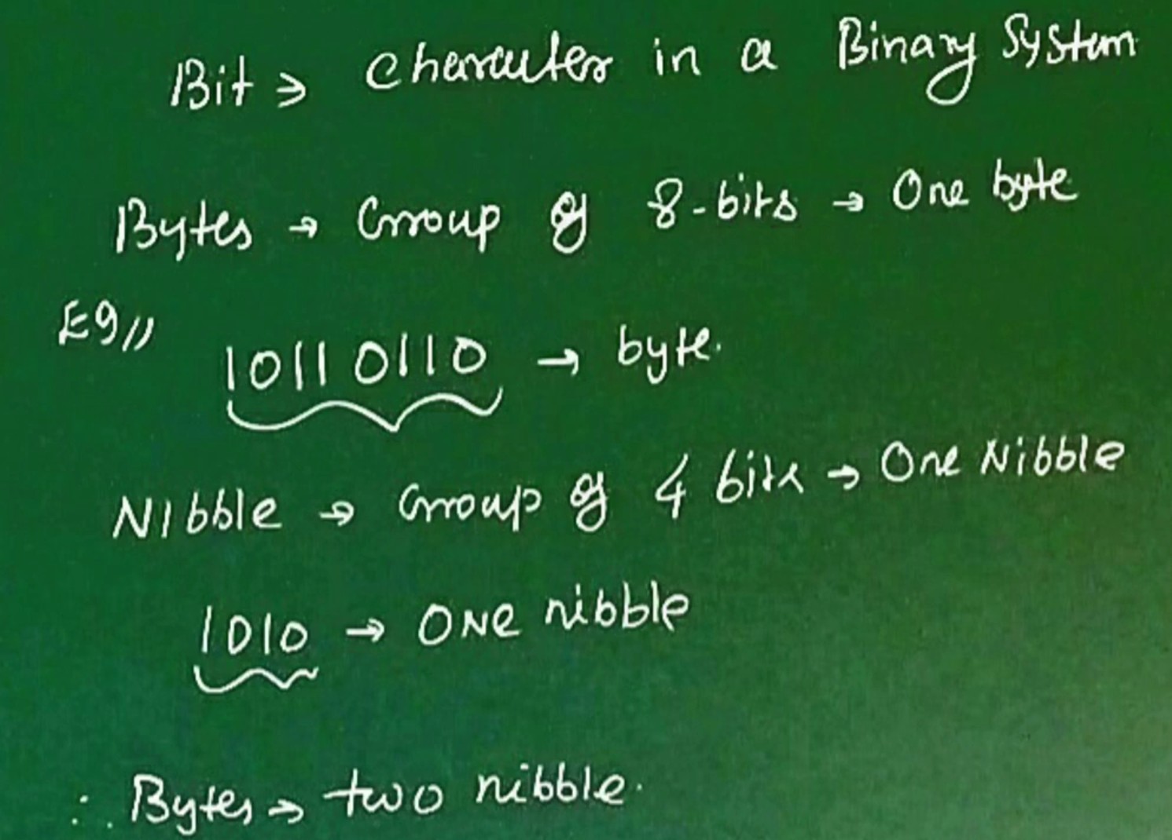

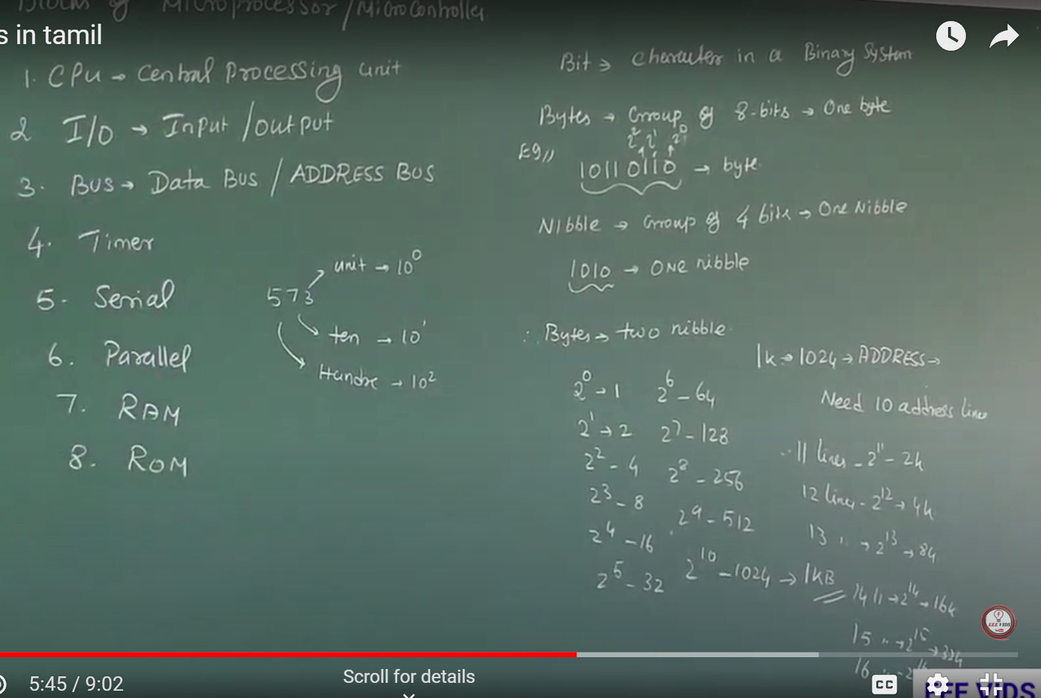

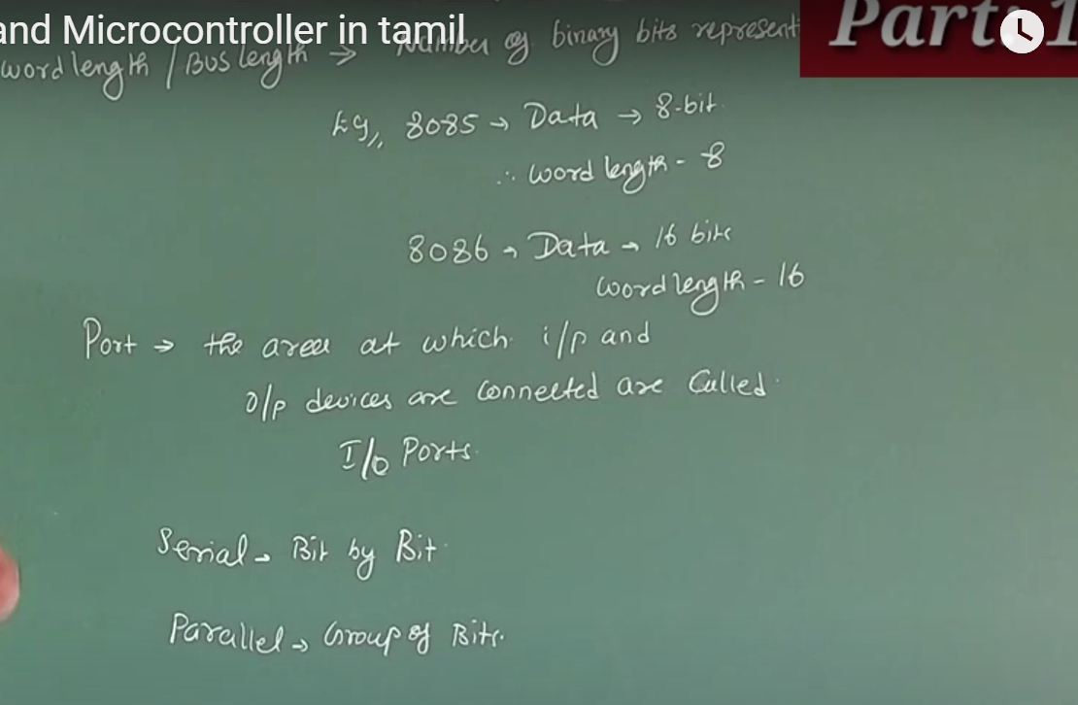

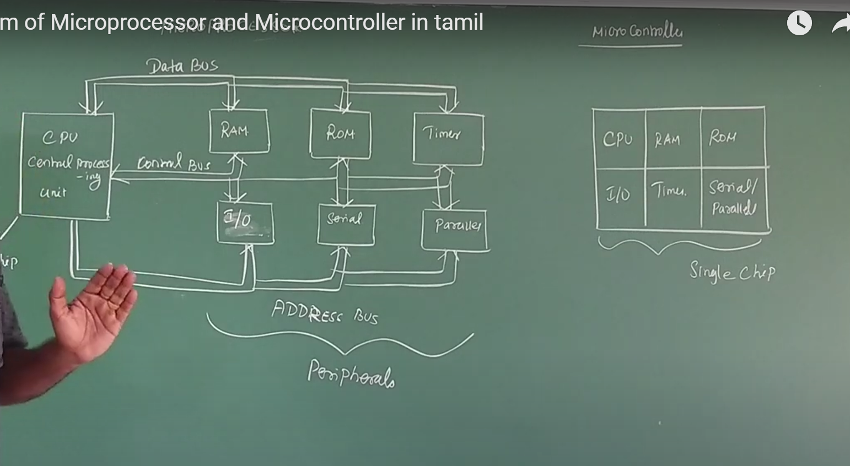

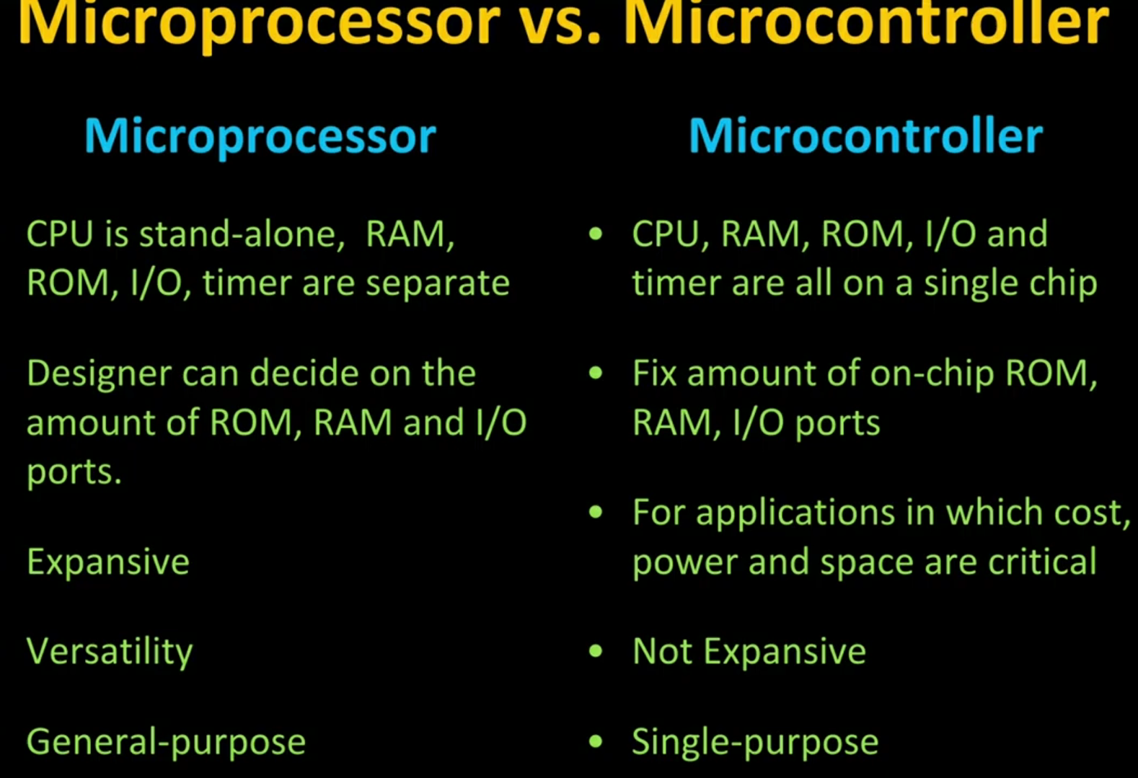

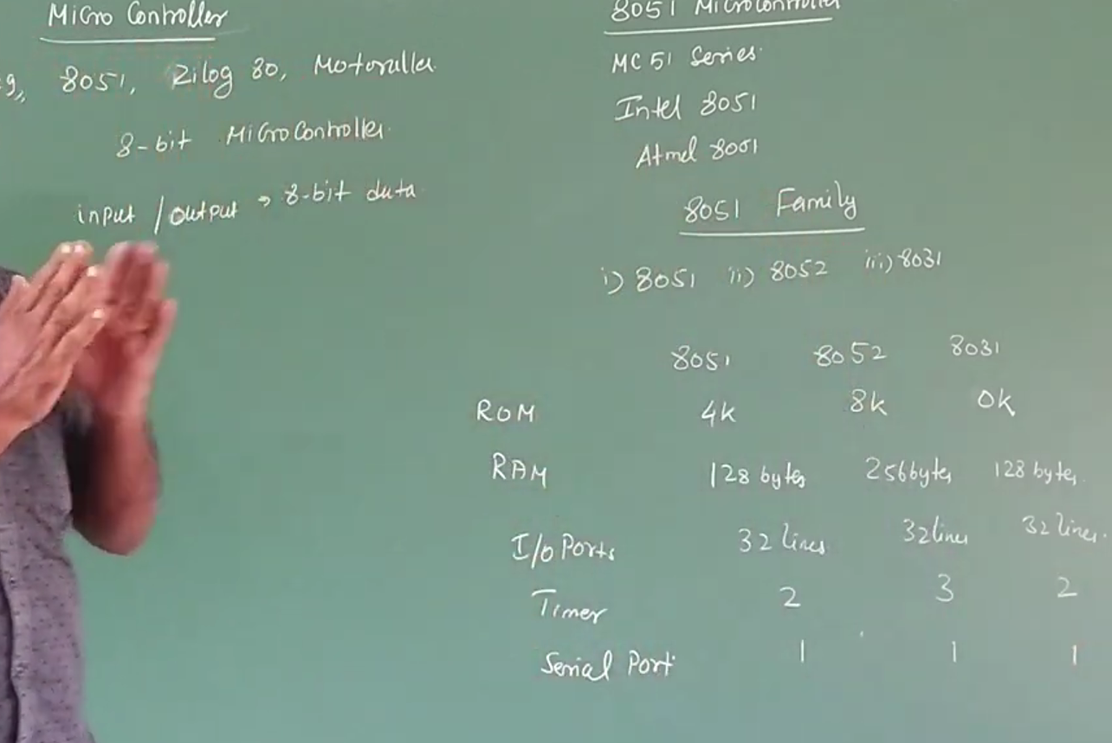

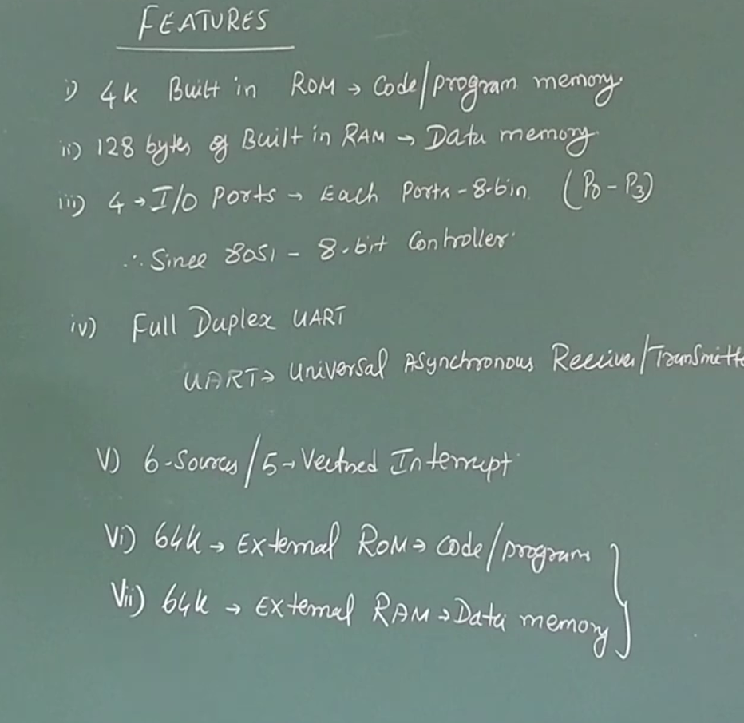
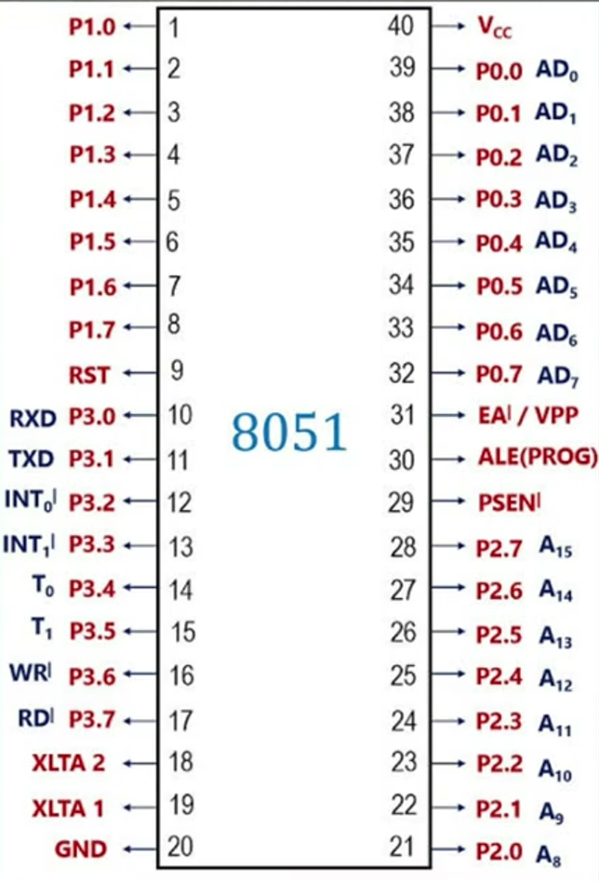
ALE- Address Latch Enable if high means address,low means data
EA -External access if low means outside memory, high means internal memory.
PSEN -program status enable if low means rom, high means ram.

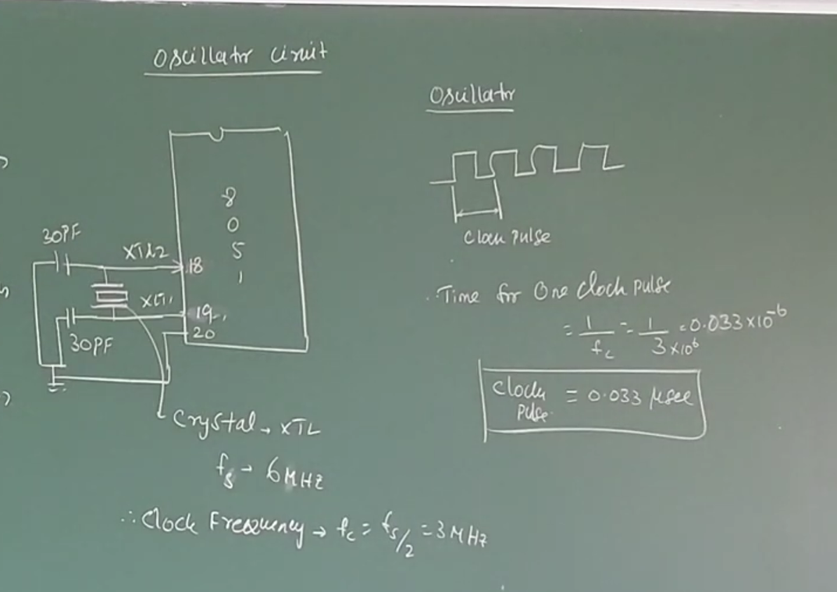
machine cycle- time taken to complete one operation i.e.) fetch address, send data, memory read cycle, write cycle, op code fetch cycle, binary code convert cycle
instruction cycle – time taken to complete one instruction. (time = total pulse taken by a instruction)
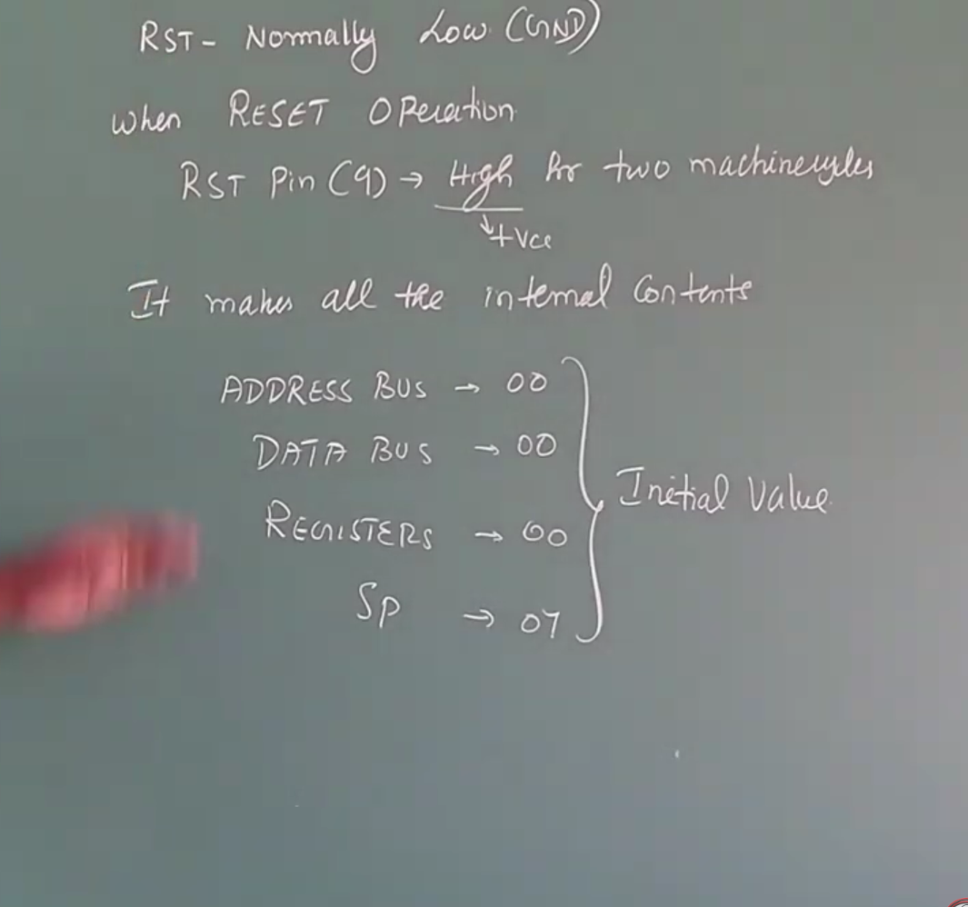
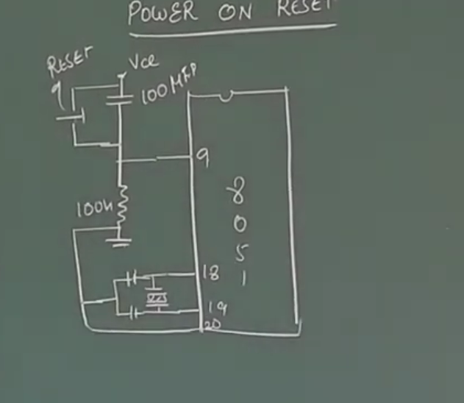
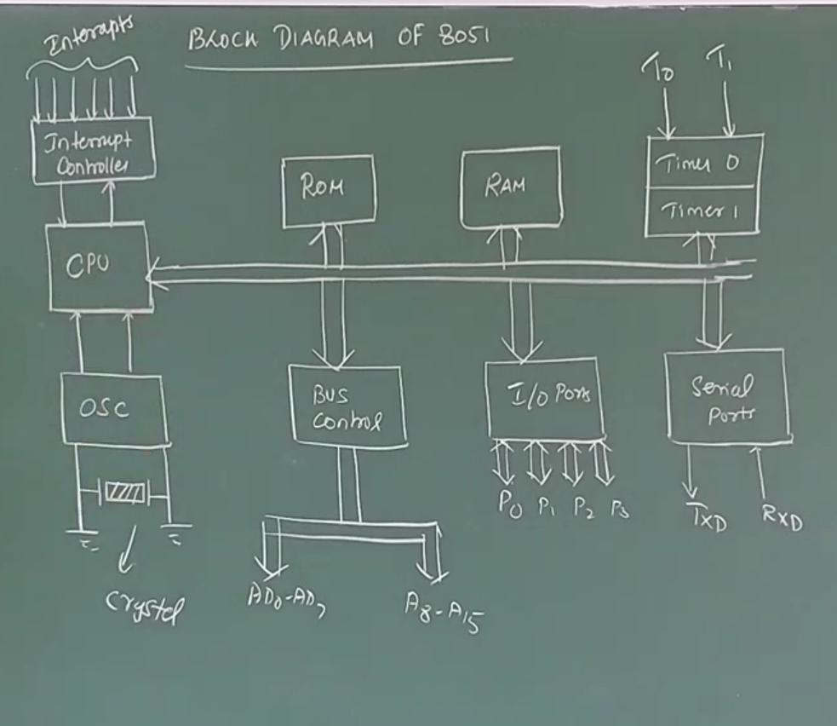

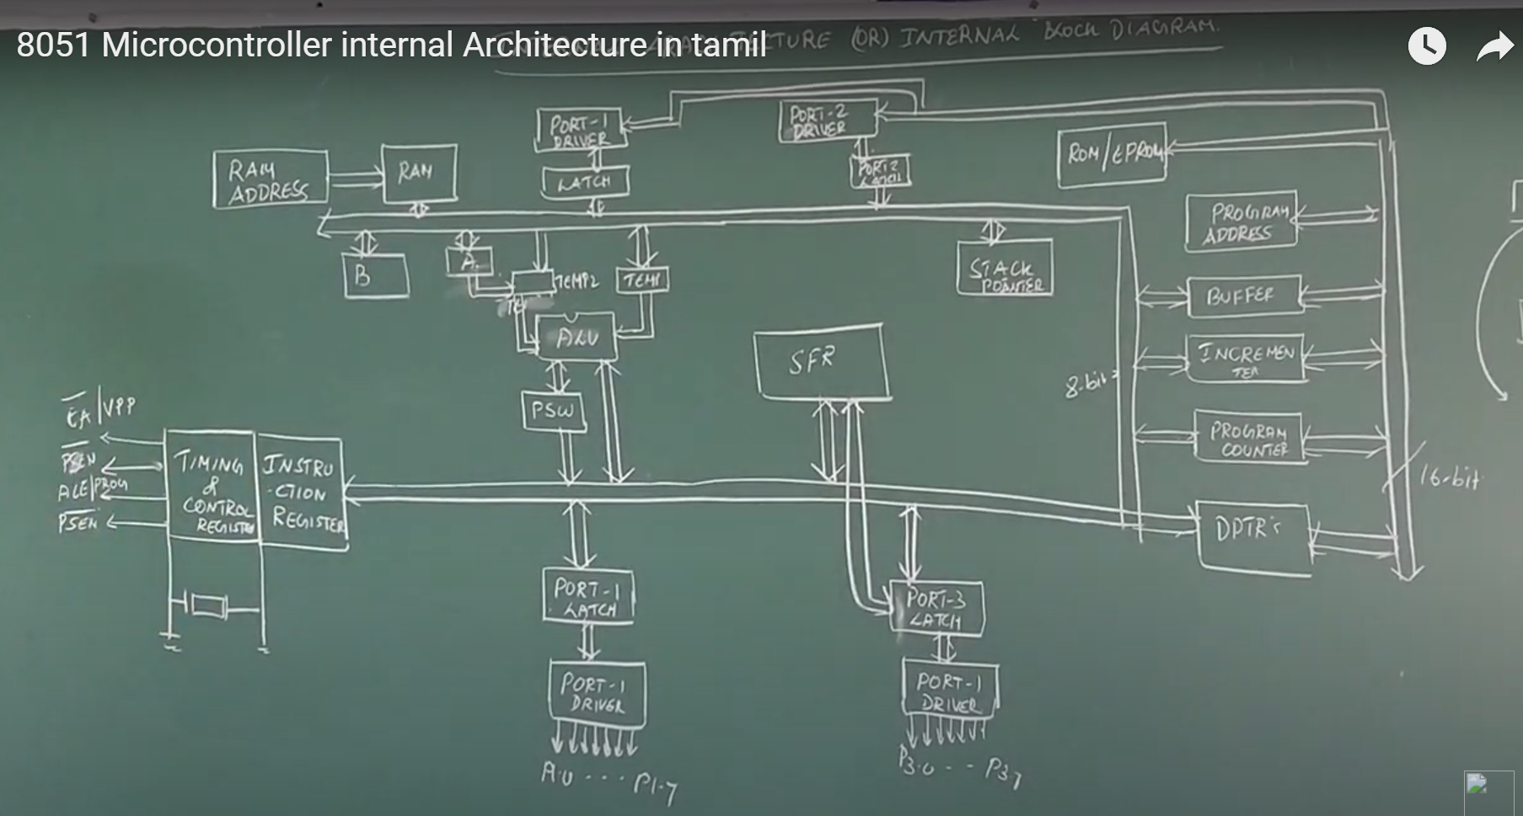

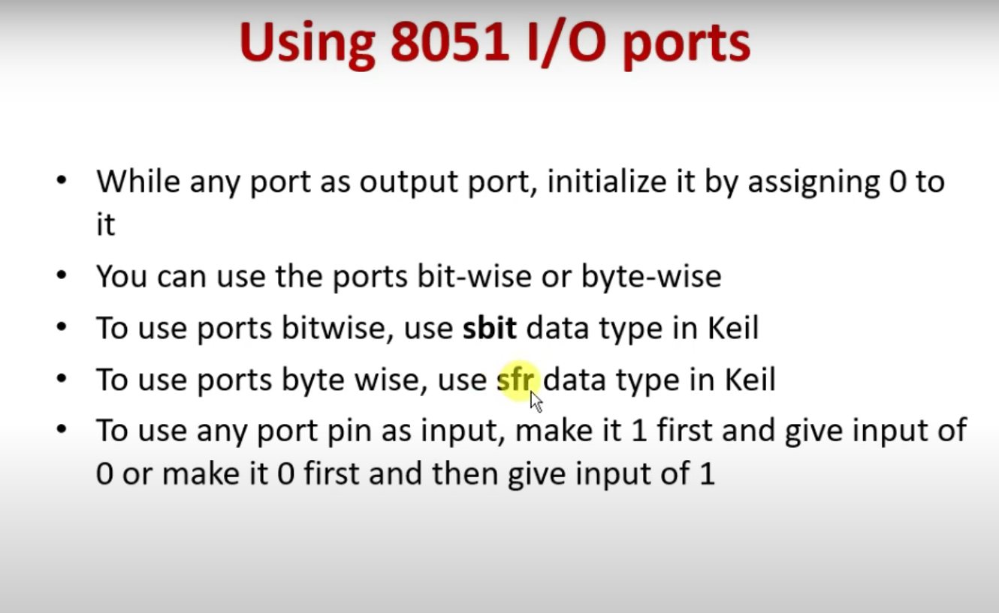

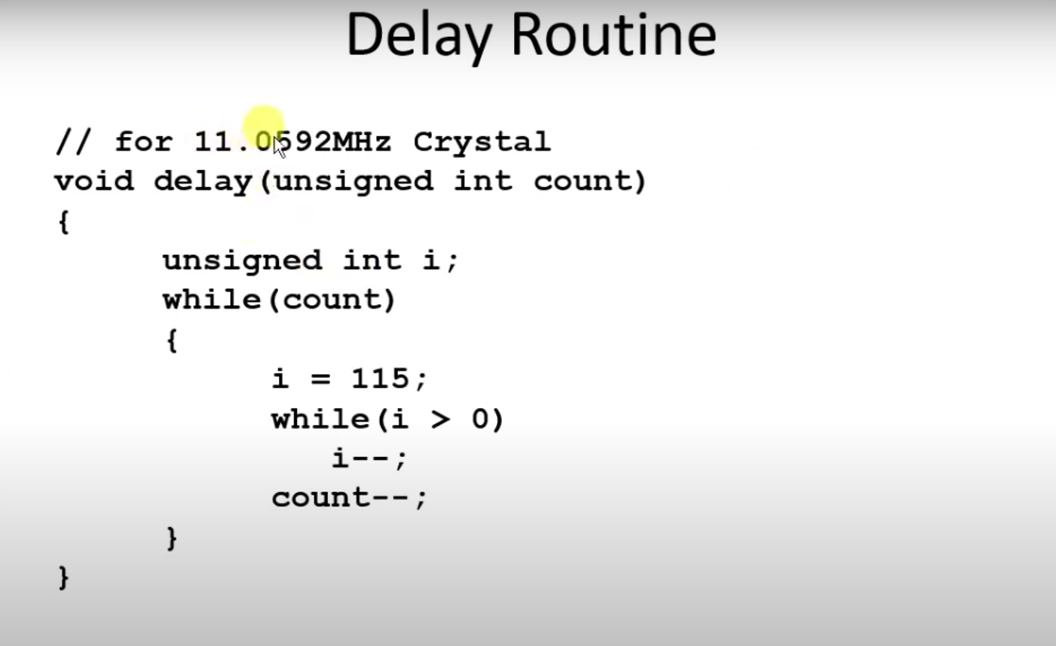

//LED BLINK PROGRAM
#include<reg51.h>
void delay(unsigned int count){
unsigned int i;
while(count){
i=115;
while(i>0)
i--;
count--;
}
}
void main(){
while(1){
P2=0x00;
delay(1000);
P2=0xFF;
delay(1000);
}
}
Or
#include<reg51.h>
void delay(unsigned int count){
unsigned int i;
while(count){
i=115;
while(i>0)
i--;
count--;
}
}
sbit ledB=P2^0;
void main(){
P2=0x00;
while(1){
ledB=0;
delay(1000);
ledB=0;
delay(1000);
}
}
//For alternate LED glow
void main(){
while(1)
{
P2=0xAA;
delay(1000);
P2=0x55;
delay(1000);
}
}

